

***DATA ENGINEERING***

***WEEK-02***

***TASK-07***

*Submitted to*

***Sir Muhammad Ahtisham***

*Submitted by*

***Aabra Malik***

***Create the table named Student and making Roll number an identity***

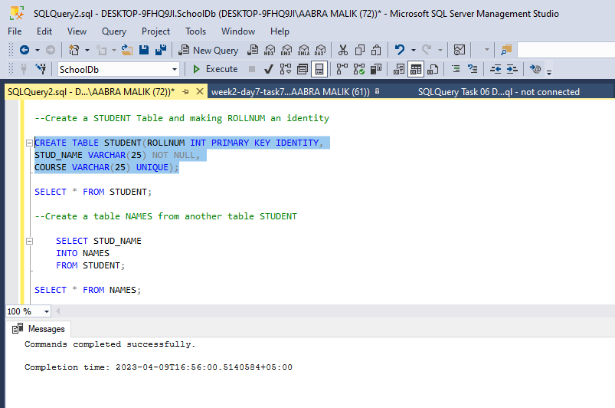

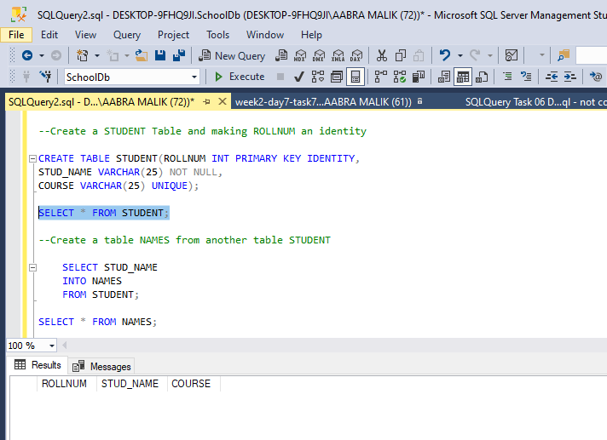

***Creating a table from another table***

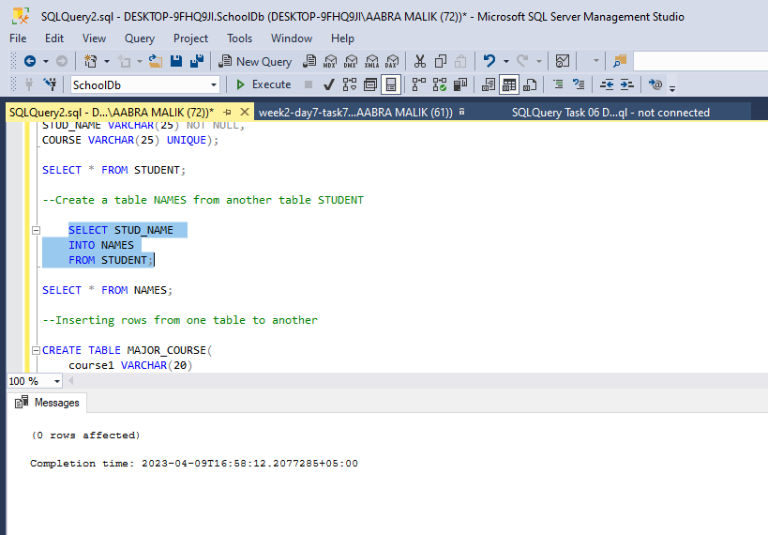

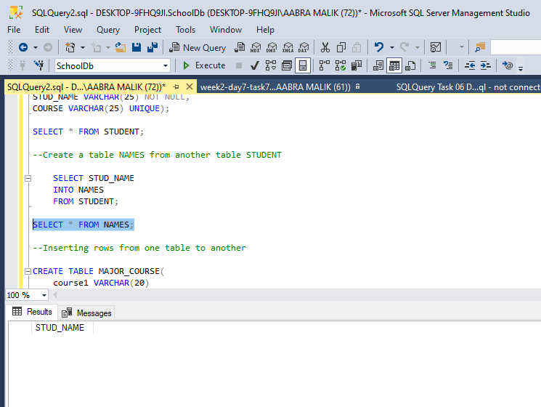

***Inserting rows from one table to another***

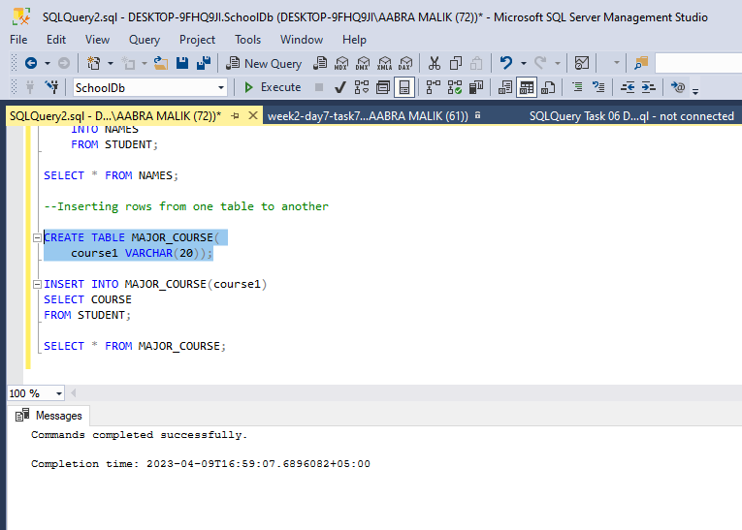

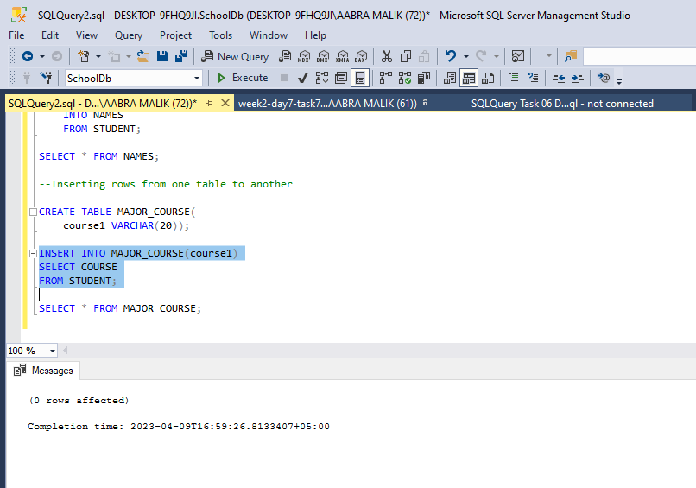

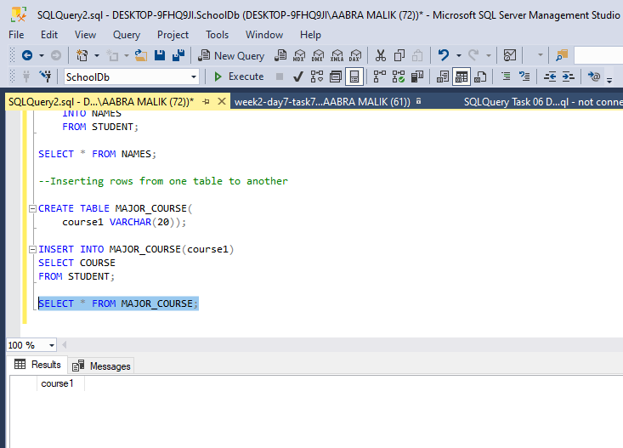

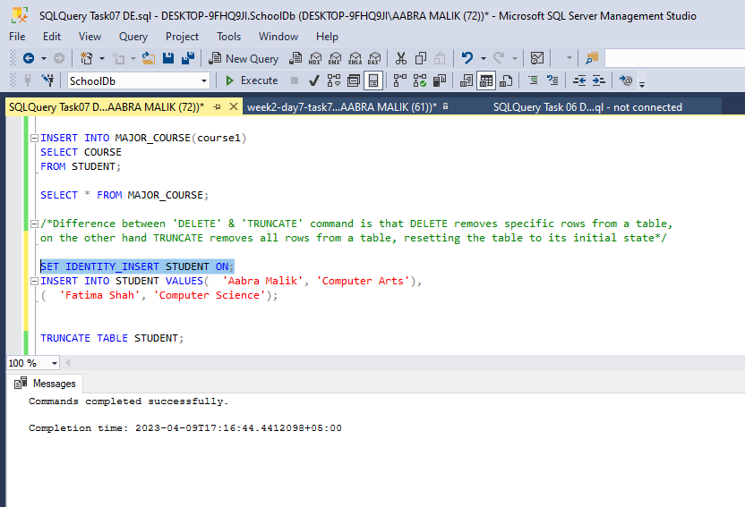

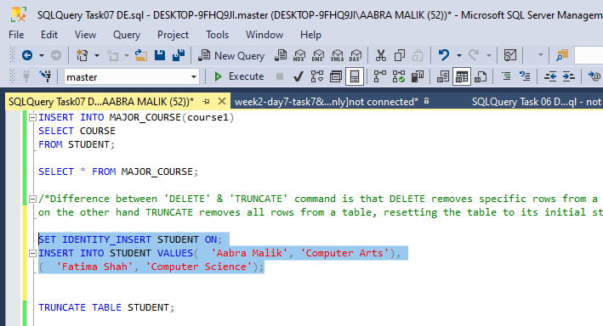

***Truncate Command***



